StandUp For Kids

Overall Introduction
StandUp for Kids is a general charitable organization devoted to breaking the cycle of juvenile homelessness in communities. They have been caring for homeless and at-risk kids since 1990, moving them from disasters to connections. Through housing assistance, mentorship, drop-in centers, and street outreach, they provide youth with a sense of safety, hope, and belonging. They have received the highest independent grade for fiscal stewardship of all contributions.
The organization has partnered with Kia Motors of America. It is grateful for acknowledging them as leaders in the battle against juvenile homelessness. StandUp for Kids is also thankful for being Kia Motors recipients through their #YardsAgainstHomelessness and #GiveItEverything fundraising initiatives (StandUp For Kids, n.d.). The organization is delighted to be affiliated with, promote, and collaborate with various youth-serving and advocacy groups, including True Colors United, Housing not Handcuffs, National Runaway Safeline, and Member NN4Y at the national level.
Mission
StandUp for Kids' mission is to end the loop of youth homelessness, which they have accomplished in communities across the United States, one kid at a time. Their vision is to create communities in which all adolescents know they are cared for, feel valued, and have a support structure to assist their transition from surviving to flourishing as fast as possible.
Their values include the belief in developing a unique and contagious approach to helping homeless kids. Similarly, they must be care activists rather than case administrators, friends rather than service benefactors, community coordinators rather than the only basis of relief. They consider every adolescent capable of making their own choices and provide all adolescents with a choice and voice. In addition, they value each young person's uniqueness, beliefs, and preferences. Likewise, they never make a promise that they cannot keep. Lastly, they find innovative and cost-effective solutions to various individual and societal issues and engage as role models.
Situational Analysis
In almost every location where they work, volunteers wander the roads in identified hotspots and additional places where kids assemble to provide nourishment, clothes, sanitation items, relevant facts, and recommendations. StandUp helpers make it a point to be available at reliable times to establish connections with destitute children and guarantee they are linked to other initiatives the organizations provide and vital community resources they trust.
Street Outreach consultants go out onto the streets to try to reach out to homeless children. There is a projected 31,000 homeless and housing uncertain youth between 12-24 in Orange County. The most pressing need for homeless and street children is ongoing care and genuine assistance. An effective street outreach program is concerned with more than just identifying homeless children who want to remain in an accommodation region. While recognizing children who may need accommodation assistance, it should be offered to children living on the streets. Likewise, accommodation should be provided to kids who are not ready for more of the institution, are afraid to go to a rescue center, have a criminal history, are frightened of confinement, or are scared of being sent home.
The organization provides basic and continuing assistance through Street Outreach (17 of our 18 sites), Outreach Hubs (9 of our 18 places), Mentoring (8 of our 18 places), and Housing Provision (8 of 18 localities) (StandUp for Kids, n.d.). Separate from these programs, the organization labor to evaluate adolescents in necessity, link them to possessions that could assist them during need, and assist them in developing strategies to exit their unsustainable and unfair conditions and better stability.
SWOT Analysis
Strengths
- Committed donors - staff: The organization has four platinum donors, ten gold donors, 14 silver doors, and 13 bronze donors. Orange County's team consists of 12 staff members, 15 members of the local advisory committee, and 140+ committed volunteers.
- Strong connection to each: Annual events like the Annual StandUp for Kids Denim & Diamonds Gala held on September 25th, Run/ Walk to end youth homelessness, and annual car shows create a strong connection.
- The chapter is adaptable: The organization provides each chapter with the freedom to handle local concerns relevant to their communities' needs. They do this through the Roadmap to Success (RMTS), Journey to Self-Sufficiency (JTS), WeDeliver, STEM program, Entrepreneurship program, OC Colleges project.
- Plans are well organized: The organization has a well-communicated vision focusing on five key areas, including;
- Reaching 1000 youths yearly, including program enrollment of 660 youths.
- Maintaining a 90% success rate for enrolled youths sustaining stability.
- Raising $2,200,000 to improve programs and expand impact.
- Lots of material for media: There are numerous stories posted on the organization's website from former youth that is inspiring. For instance, "I Heart StandUp," shows the successes achieved by the organization in transforming youth's lives.
- Stable, flexible, and consistent development and assurance, even through hardship: The story of Chief, published on September 22nd, 2021, reveals how youths have persevered during the pandemic.
- Transparency - financial reports
  - What is bought by the contributions showing transparency:
    - $150 - One week's groceries for three adolescents
    - $69 - One monthly bus pass for a homeless youngster
    - $31 - The needed fee for a California State ID
    - $175 - GED examination cost for one individual
    - $600 for a one-month rental of a room
- 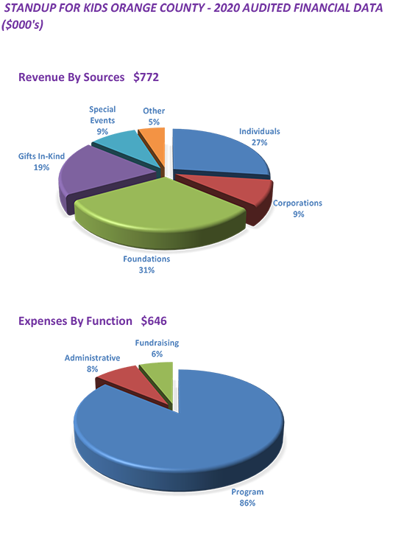
Committed donors. StandUp for Kids' most significant strength is its passionate, supportive base of donors. They also have committed staff. Even though the turnover is significant, the whole team is deeply committed to the objective. Lastly, their regional presence has deeply entrenched local relationships in communities around the country. Strong connections to the community and chapters are adaptable to where they are located.
Weaknesses
- Lack of awareness about the org: The organization has only 1,427 followers on Twitter and 5.2k followers on Facebook, indicating that many people are unaware of the organization.
- Lack of media attention/traffic even though the website and social media are very detailed: The organization has not explored the power of social media marketing.
- Videos and visuals are not captivating: There is little use of visual elements on the website.
- Many donors are individuals and not larger companies: For instance, most individual donors fall under the bronze donors’ categories.
- Lack of partnerships with consistent sources of volunteers and staff: The organization does not offer paid positions thus constant sources of volunteers is not guaranteed.
Donors are getting older. One issue with having a base of contributors who have been contributors for years is that most of these funders will be gone shortly.
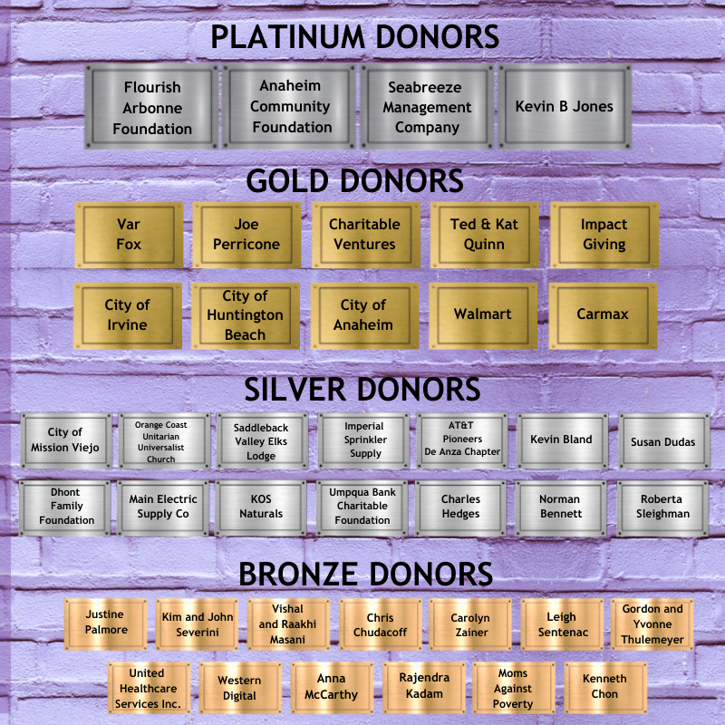
Opportunities
- Acquiring partnerships → more donors/support/awareness: The organization has the capacity of gaining from any willing donors through their donation page that offers anyone visiting the website an opportunity to offer donations.
- Improving social media presence: The organization can create awareness and increase its following using online marketing strategies and platforms like email marketing, social media marketing, and targeted advertisement in Orange County.
- Increasing awareness of youth stories → more attention to the organization as a whole: They can post more success stories on their social media platforms and use them as advertisement material in Orange County.
- Promoting existing operations in OC: The organization can team up with a public figure of an influencer to promote their operations in OC.
- Partner with schools on training programs to satisfy GE (Chapman service inquiry, other school’s community service) requirements (mutually beneficial relationship): They can achieve this by adhering to their vision, which is offering program services, housing, fundraising, communication, and relationships aiming at reaching 1000 youths yearly while maintaining a 90% success rate.
The most significant opportunity the organization has is acquiring partnerships. Such associations provide several options for success. StandUp for Kids is delighted to have received the best possible ratings from industry whistleblowers Guidestar and Charity Navigator. This is because they practice financial openness and guarantee that each dollar given is utilized following their goal, thus attracting investors. Volunteers returning after staying in the homes for extended periods have enormous potential for promoting awareness and funds. Reaching out to these volunteers both before they go and after they return might assist in cementing the volunteer's connection to both investors and the organization.
Threats
- Rival organizations, particularly those with a larger presence
- Mary’s Kitchen, Youth Centers of Orange, Huntington Youth Center, CASA Youth Center, Family Promise of Orange County, Orangewood Foundation are among the organizations stiffly competing with StandUp for kids in Orange County.
- Effects of pandemic: COVID-19 has exacerbated the typical worries of homeless kids by bringing about changes in work, housing, and education. In the previous week, 32% of those polled slept in three or more separate places. Access to fundamental necessities has grown increasingly complex, with 66 percent of those surveyed reporting that they require more than five resources, with employment ranking first. In that order, food/healthy food, overall health, shelter, access to a computer, and Wi-Fi are the following most critical primary resources.
- Small population: Most people within Orange County are looking to earn a living; thus, volunteering becomes a significant concern, especially if they are getting no or little return.
Rival Organizations are the main challenge. The growing number of similar organizations is one of the most severe threats to StandUp for Kids. Several other charities provide donor trips to see sponsored children, and some of them are better supported. World Vision is one of the largest. They operate on a similar model to child sponsorship, but with a much more donor-friendly website that allows donors to select a kid. Their website also provides innovative methods to donate, such as catalog shopping or microfinance.

Objective
One primary objective of the organization would be increasing donations to reach out to a vast majority of kids who require assistance without limiting the number of children who get help.
Strategies
The first strategy the organization can use to achieve the above objective is by promoting its fundraising efforts after studying possible contributors and creating a positive image in people's minds. It is a simple, effective, and beneficial method of encouraging more individuals to give to the cause. Another strategy the organization can use is building its brand equity to achieve its targets.
Tactics
The first tactic for promotion can be done through social media or by getting a brand ambassador to attract wealthy donors. The second tactic is building brand awareness, captivating pictures and video, a typeface, a high-quality website, and text supporting brand guidelines. This raises brand familiarity and understanding and gives potential contributors confidence to donate to a reasonable cause. A well-branded nonprofit inspires individuals to contribute money by instilling confidence and trust in them. The third tactic would be updating the organization’s resources and tools when required. Continuously assessing your digital toolbox for areas in need of development will help you identify any issues and plug any gaps as needed. The fourth tactic is putting a twist on the typical fundraising strategy. The organization must not let its advocacy get too monotonous! They should keep donors interested in what is ahead by continually exploring fresh fundraising ideas. The last tactic that the organization can use is providing growth opportunities because growing donor relationships ensures the flow of donations (Guo & Saxton, 2020).

References
Guo, C., & Saxton, G. D. (2020). Social Media and Nonprofit Advocacy: The Beginning of a New Paradigm. In The Quest for Attention (Pp. 1-25). Stanford University Press.
StandUp For Kids. (n.d.). Getting Kids off the Street. https://www.standupforkids.org/

